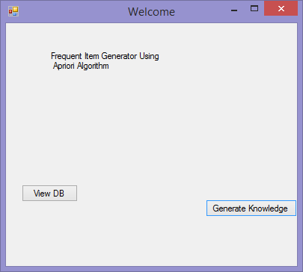

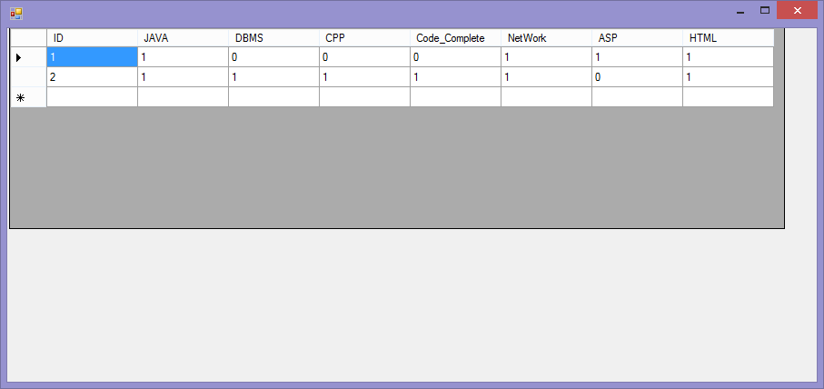

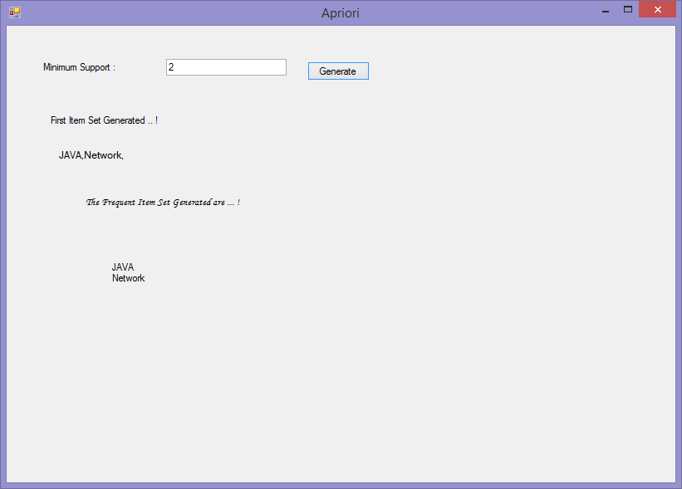

Performance And Diagnostic Report :

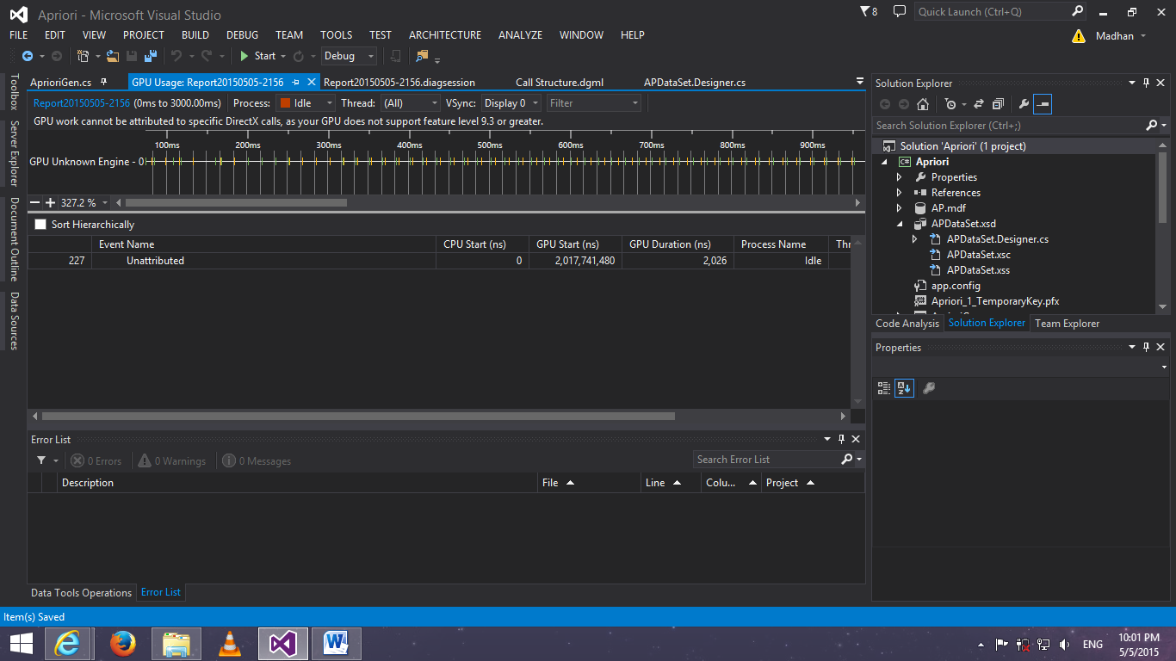

|  |  |  |  |  |  |  |  |  |  |
| --- | --- | --- | --- | --- | --- | --- | --- | --- | --- |
| Scope | Project | Namespace | Type | Member | Maintainability Index | Cyclomatic Complexity | Depth of Inheritance | Class Coupling | Lines of Code |
| Project | Apriori (Debug) |  |  |  | 80 | 82 | 7 | 68 | 499 |
| Namespace | Apriori (Debug) | Apriori.APDataSetTableAdapters |  |  | 100 | 1 | 3 | 13 | 1 |
| Type | Apriori (Debug) | Apriori.APDataSetTableAdapters | TableAdapterManager |  | 100 | 1 | 3 | 8 | 1 |
| Member | Apriori (Debug) | Apriori.APDataSetTableAdapters | TableAdapterManager | TableAdapterManager() | 100 | 1 |  | 1 | 1 |
| Type | Apriori (Debug) | Apriori.APDataSetTableAdapters | BOOKSTableAdapter |  | 100 | 0 | 3 | 9 | 0 |
| Namespace | Apriori (Debug) | Apriori |  |  | 75 | 81 | 7 | 61 | 498 |
| Type | Apriori (Debug) | Apriori | ViewDB |  | 56 | 15 | 7 | 31 | 135 |
| Member | Apriori (Debug) | Apriori | ViewDB | ViewDB_Load_1(object, EventArgs) : void | 92 | 1 |  | 3 | 1 |
| Member | Apriori (Debug) | Apriori | ViewDB | ViewDB_Load(object, EventArgs) : void | 81 | 1 |  | 2 | 3 |
| Member | Apriori (Debug) | Apriori | ViewDB | ViewDB() | 78 | 1 |  | 2 | 4 |
| Member | Apriori (Debug) | Apriori | ViewDB | readDB() : void | 65 | 2 |  | 7 | 8 |
| Member | Apriori (Debug) | Apriori | ViewDB | Progress() : void | 57 | 3 |  | 5 | 15 |
| Member | Apriori (Debug) | Apriori | ViewDB | InitializeComponent() : void | 33 | 1 |  | 22 | 94 |
| Member | Apriori (Debug) | Apriori | ViewDB | Dispose(bool) : void | 80 | 3 |  | 3 | 3 |
| Member | Apriori (Debug) | Apriori | ViewDB | dataGridView1_CellContentClick(object, DataGridViewCellEventArgs) : void | 100 | 1 |  | 1 | 0 |
| Member | Apriori (Debug) | Apriori | ViewDB | button1_Click(object, EventArgs) : void | 68 | 2 |  | 5 | 7 |
| Type | Apriori (Debug) | Apriori | Result |  | 61 | 8 | 7 | 18 | 50 |
| Member | Apriori (Debug) | Apriori | Result | Result_Load(object, EventArgs) : void | 70 | 2 |  | 7 | 5 |
| Member | Apriori (Debug) | Apriori | Result | Result() | 82 | 1 |  | 2 | 3 |
| Member | Apriori (Debug) | Apriori | Result | InitializeComponent() : void | 45 | 1 |  | 12 | 38 |
| Member | Apriori (Debug) | Apriori | Result | Dispose(bool) : void | 80 | 3 |  | 3 | 3 |
| Member | Apriori (Debug) | Apriori | Result | button1_Click(object, EventArgs) : void | 100 | 1 |  | 2 | 1 |
| Type | Apriori (Debug) | Apriori | Program |  | 81 | 1 | 1 | 3 | 3 |
| Member | Apriori (Debug) | Apriori | Program | Main() : void | 81 | 1 |  | 3 | 3 |
| Type | Apriori (Debug) | Apriori | Form1 |  | 68 | 9 | 7 | 16 | 48 |
| Member | Apriori (Debug) | Apriori | Form1 | InitializeComponent() : void | 46 | 1 |  | 11 | 34 |
| Member | Apriori (Debug) | Apriori | Form1 | Form1_Load(object, EventArgs) : void | 83 | 1 |  | 3 | 2 |
| Member | Apriori (Debug) | Apriori | Form1 | Form1() | 82 | 1 |  | 2 | 3 |
| Member | Apriori (Debug) | Apriori | Form1 | Dispose(bool) : void | 80 | 3 |  | 3 | 3 |
| Member | Apriori (Debug) | Apriori | Form1 | button2_Click(object, EventArgs) : void | 85 | 1 |  | 3 | 2 |
| Member | Apriori (Debug) | Apriori | Form1 | button1_Click_1(object, EventArgs) : void | 85 | 1 |  | 3 | 2 |
| Member | Apriori (Debug) | Apriori | Form1 | button1_Click(object, EventArgs) : void | 85 | 1 |  | 3 | 2 |
| Type | Apriori (Debug) | Apriori | Charts |  | 62 | 11 | 7 | 22 | 55 |
| Member | Apriori (Debug) | Apriori | Charts | InitializeComponent() : void | 50 | 1 |  | 12 | 26 |
| Member | Apriori (Debug) | Apriori | Charts | Dispose(bool) : void | 80 | 3 |  | 3 | 3 |
| Member | Apriori (Debug) | Apriori | Charts | Charts_Load(object, EventArgs) : void | 100 | 1 |  | 1 | 0 |
| Member | Apriori (Debug) | Apriori | Charts | Charts() | 82 | 1 |  | 2 | 3 |
| Member | Apriori (Debug) | Apriori | Charts | button1_Click(object, EventArgs) : void | 49 | 4 |  | 9 | 23 |
| Member | Apriori (Debug) | Apriori | Charts | backgroundWorker1_DoWork(object, DoWorkEventArgs) : void | 100 | 1 |  | 1 | 0 |
| Type | Apriori (Debug) | Apriori | AprioriGen |  | 49 | 37 | 7 | 26 | 207 |
| Member | Apriori (Debug) | Apriori | AprioriGen | readDB() : void | 58 | 5 |  | 5 | 13 |
| Member | Apriori (Debug) | Apriori | AprioriGen | InitializeComponent() : void | 36 | 1 |  | 13 | 76 |
| Member | Apriori (Debug) | Apriori | AprioriGen | Dispose(bool) : void | 80 | 3 |  | 3 | 3 |
| Member | Apriori (Debug) | Apriori | AprioriGen | button2_Click(object, EventArgs) : void | 81 | 1 |  | 4 | 3 |
| Member | Apriori (Debug) | Apriori | AprioriGen | button1_Click(object, EventArgs) : void | 52 | 3 |  | 8 | 23 |
| Member | Apriori (Debug) | Apriori | AprioriGen | AprioriGen() | 74 | 1 |  | 3 | 5 |
| Member | Apriori (Debug) | Apriori | AprioriGen | AprioriGen() | 75 | 1 |  | 1 | 4 |
| Member | Apriori (Debug) | Apriori | AprioriGen | Apriori_Load(object, EventArgs) : void | 100 | 1 |  | 1 | 0 |
| Member | Apriori (Debug) | Apriori | AprioriGen | Apriori_Cal() : void | 31 | 21 |  | 9 | 80 |
| Type | Apriori (Debug) | Apriori | APDataSet.BOOKSRow |  | 100 | 0 | 2 | 1 | 0 |
| Type | Apriori (Debug) | Apriori | APDataSet.BOOKSDataTable |  | 100 | 0 | 4 | 4 | 0 |
| Type | Apriori (Debug) | Apriori | APDataSet |  | 100 | 0 | 3 | 8 | 0 |
|  |  |  |  |  |  |  |  |  |  |